**1. Calculating the Final Grade:** public class StudentGrade { public static void main(String[] args) { String studentName = "Alice"; int assignmentScore = 85; int midtermScore = 78; int finalExamScore = 92; String finalGrade;

double finalScore = (assignmentScore * 0.3) + (midtermScore * 0.3) +

(finalExamScore * 0.4);

if (finalScore >= 90)

{

finalGrade = "A";

}

else if (finalScore >= 80)

{

finalGrade = "B";

}

else if (finalScore >= 70)

{

finalGrade = "C";

}

else if (finalScore >= 60)

{

finalGrade = "D";

}

else

{

finalGrade = "F";

}

System.out.println(studentName + "'s final grade is " + finalGrade + ".");

}

}

**Output:**

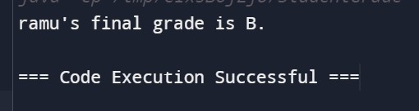

**2. Calculating the Mileage of a Car:**

public class CarMileage

{

public static void main(String[] args)

{

String carModel = "Toyota Camry"; double distanceTraveled = 300; double fuelConsumed = 15; double mileage;

mileage = distanceTraveled / fuelConsumed;

System.out.println("The mileage of " + carModel + " is " + mileage + " miles per gallon.");

}

}

**Output:**

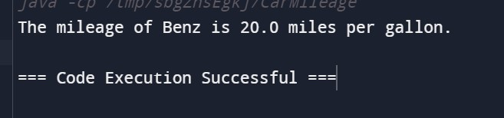

**3. Calculating the Fine for Overdue Books:**

public class LibraryFine {

public static void main(String[] args) { String bookTitle = "Harry Potter"; int daysOverdue = 5; double finePerDay = 0.50; double totalFine;

totalFine = daysOverdue * finePerDay;

System.out.println("The fine for " + bookTitle + " is $" + totalFine + ".");

}

}

**Output:**

